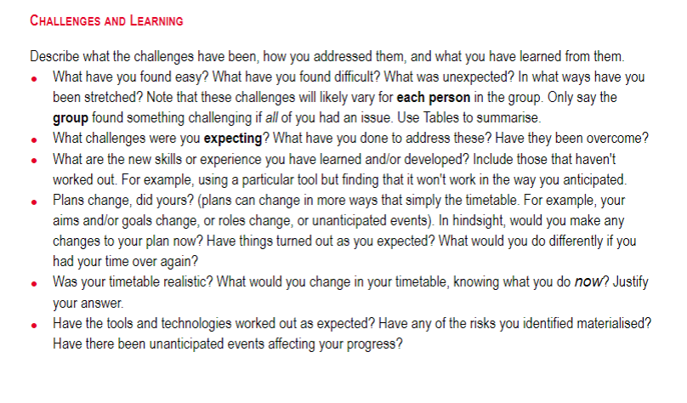

* Communication
  + Initial challenges where we didn’t have roles
  + Challenges with “missing” people

The group had some initial issues collaborating together as we had just met and needed to start work immediately. With no clearly defined roles between us, this problem caused some minor communication issues. When the roles were more defined, we had an easier time giving clear instructions to one another. Another issue we came across, communication-wise, was members not communicating absences from meetings. This has caused an unreliable work schedule and has not been fixed.

* Planning
  + Everyone had their own ideas
  + Clearly defined features missing causing team to not be on same page

In our planning stage, everyone came together with their own ideas. We talked about what we wanted the project to look like and the features within it. However, with the amount of ideas between us and without having taken notes, confusion between the team on what the project looked like happened. This caused many discussions throughout the project on what the features looked like which could have been avoided.

* Organisation
  + Work finished slower than expected caused backlogs

Due to inexperience, the group underestimated what it would take to complete the project. Adding onto a large scope, when work finished slower than expected, it caused us to re-evaluate the scope of the project.

* Late join
  + 2 of us joined a week into the project

Long and I joined the other group members a week into the project start which caused the team to play “catch-up” in planning the project. I believe the group came to a quick decision on our project but due to this, I think we didn’t have a clear goal.

* Experience
  + No experience other than 2 of us

Within the group, only myself and Long had experience working on game projects beforehand. This was a relatively minor issue as the group was eager to learn and Long and I gave tutorials and assistance to other members who needed help, especially with specific programs like Unity or Blender.